Brute Force Machine
Walkthrough Manual

- Introduction
The Web Application Pentesting (WAP) Brute Force Portal is an interactive and controlled environment designed to demonstrate and educate on the principles of brute force attacks against web applications. This platform, built to simulate real-world scenarios, allows users to engage in ethical hacking exercises to understand how these vulnerabilities are exploited. The portal offers a clear, three-tiered difficulty system—Easy, Medium, and Hard—to provide a progressive learning experience. By navigating these challenges, you will gain critical insights into the mechanics of brute force attacks and the importance of implementing robust authentication and security measures to protect web applications.

- Objectives
- Easy Level: To demonstrate a basic brute force attack against an unmitigated login form.

- Storyline
You are a cybersecurity consultant hired to conduct a penetration test on a fictional web application's user authentication system. Your client is concerned about the potential for credential-guessing attacks. Your mission is to systematically assess the login page's resilience by attempting to gain unauthorized access to a specific account. The test will be conducted in one simple phase which is
- Easy Mode: The login page has no defenses. Your task is to use a simple password list and an automated tool to quickly find the correct credentials.

- Walkthrough
Step 1: using netdiscovery find the ip and search for open ports and search deep about you findings and try to understand it.

Once you get the brute force login page Get PHPSessionID

- Right click anywhere on the webpage and select Inspect to open the developer tools.
- Navigate to the Network tab enter details on the brute force login and capture data
- Alternatively, you could go to the Storage tab and look for the cookies section.
- Here, you’ll find the PHPSESSID value, which is essential for maintaining the session during our brute force attack.
- Make a note of this value, as it will be used in the attack.

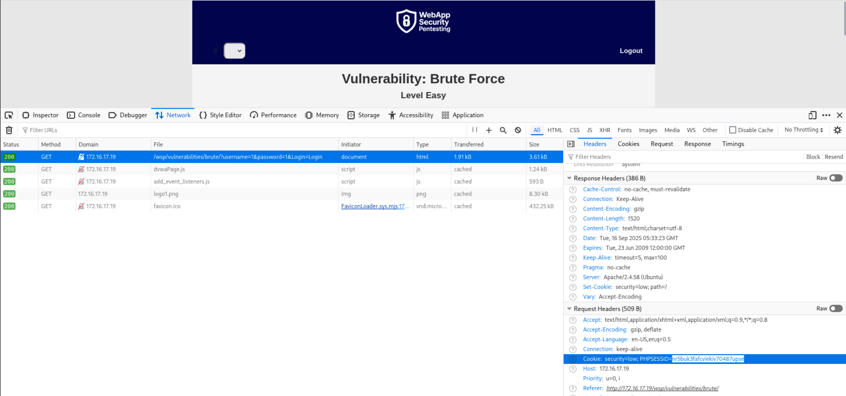

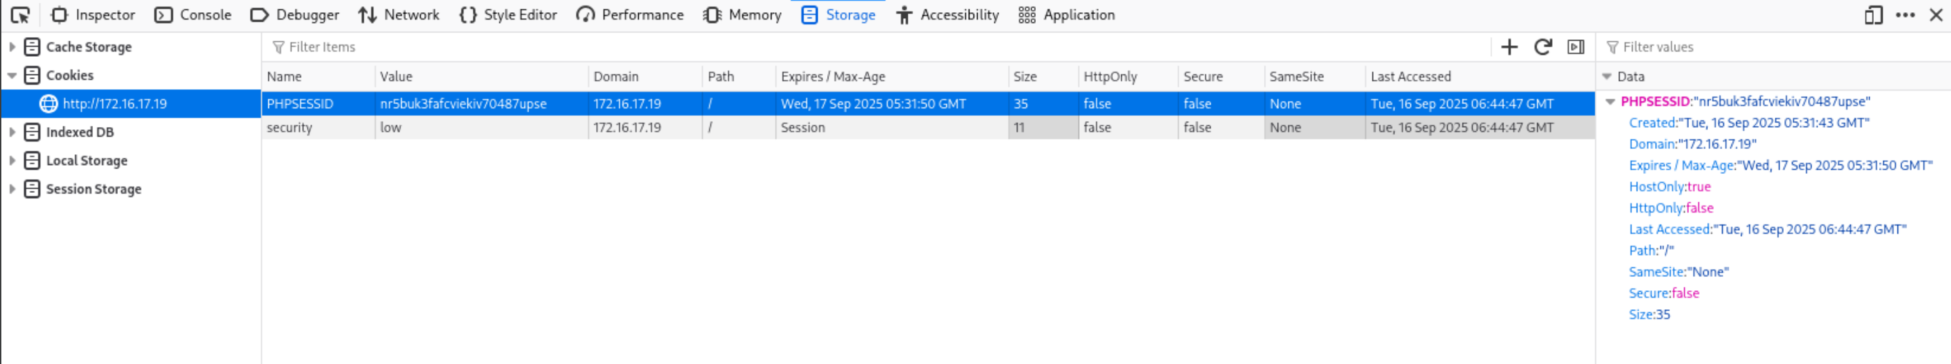

Step 2: Executing Brute Force Attacks
- With Hydra using the PHPSessionID
The general structure of the Hydra command for http-get-form is as follows:
hydra -l admin -P /usr/share/seclists/Passwords/xato-net-10-million-passwords-1000.txt 172.16.17.19 http-get-form "/wsp/vulnerabilities/brute/:username=^USER^&password=^PASS^&Login=Login:H=Cookie:PHPSESSID=nr5buk3fafcviekiv70487upse;security=low:F=Username and/or password incorrect."
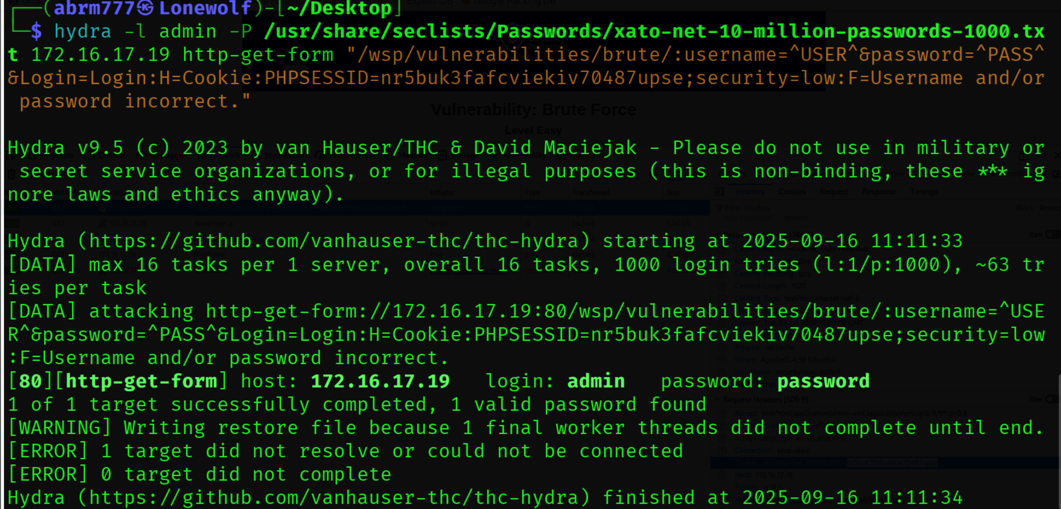

- Brute Forcing the Admin Password with Burp Suite

Step 3: Install Foxy Proxy Extension on Firefox and set it up
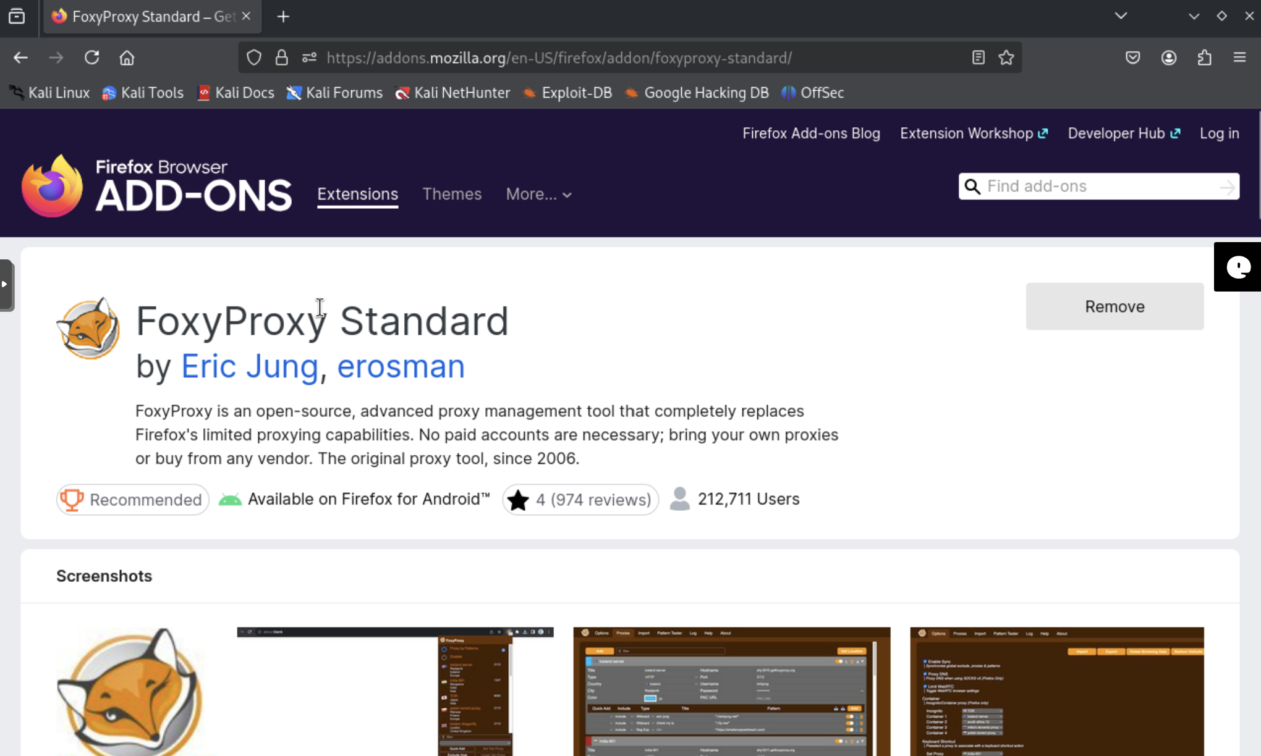

- Click on the extension and open foxy proxy
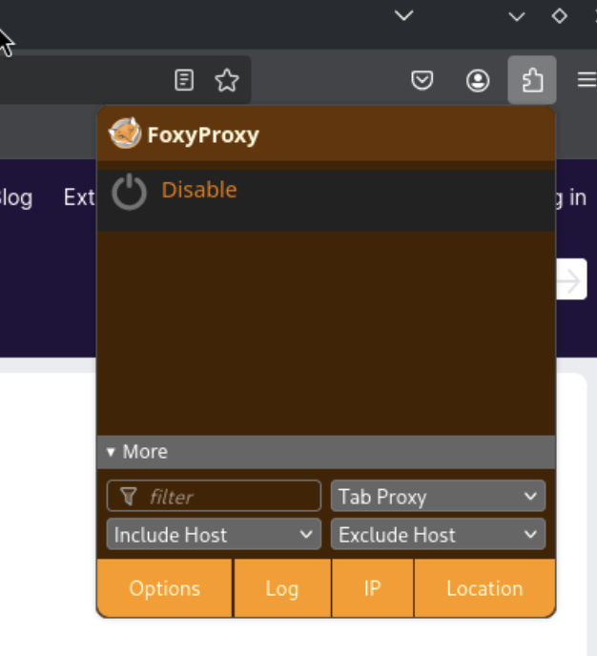
- Click on Options and go to the Proxies Tab and Click on Add
- You will get the options to add hostname and port so that out traffic gets intercepted into the port and Ip address

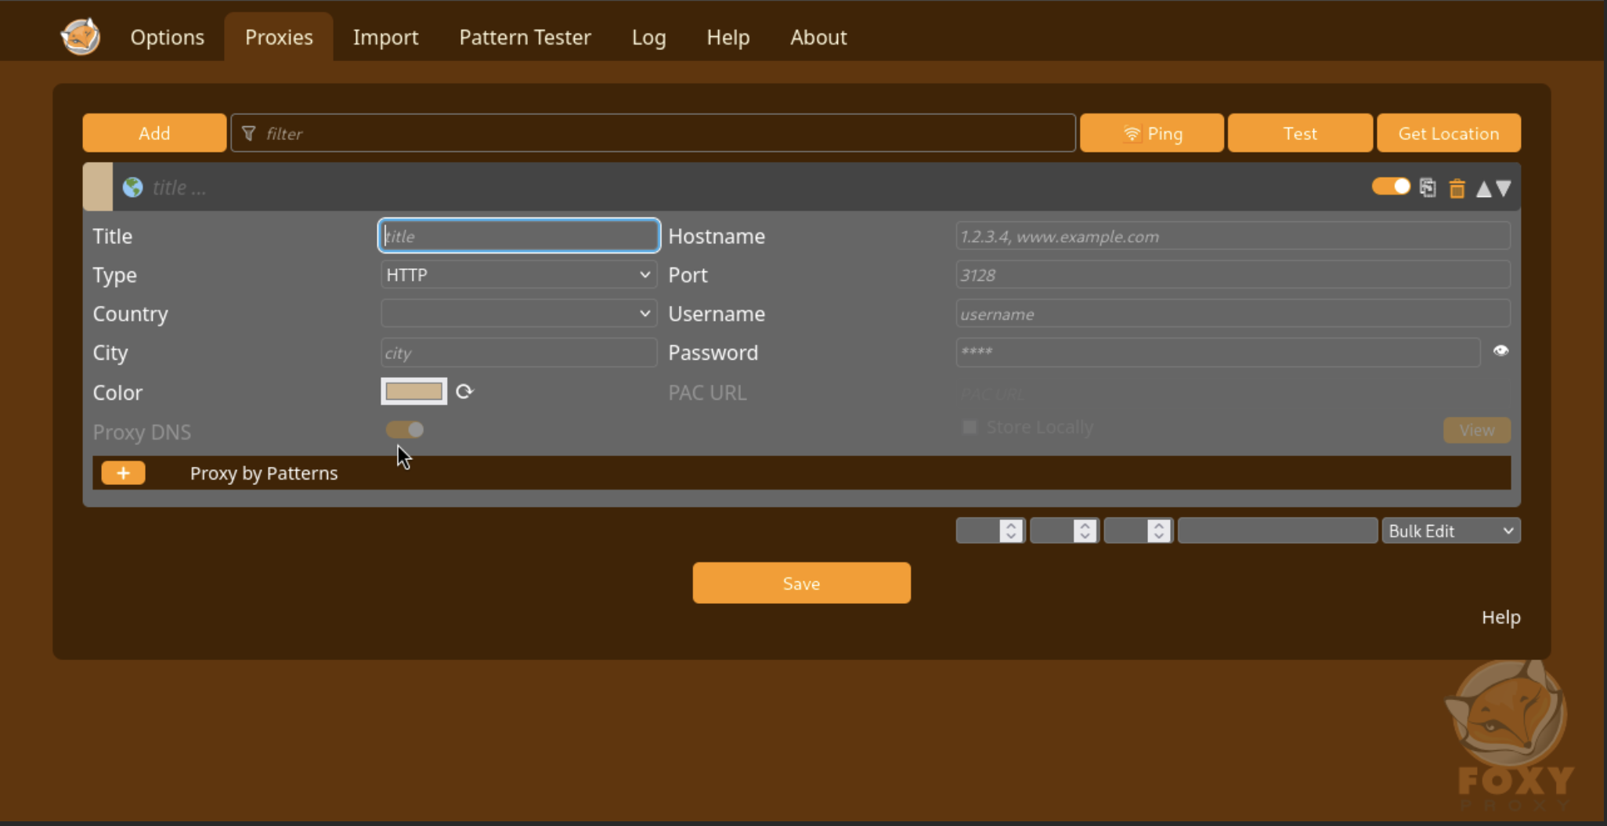

Step 4: Intercept traffic on burp suite and import certificate

- Open you Burp Suite Application select Temporary Project and click next then click on start Burp

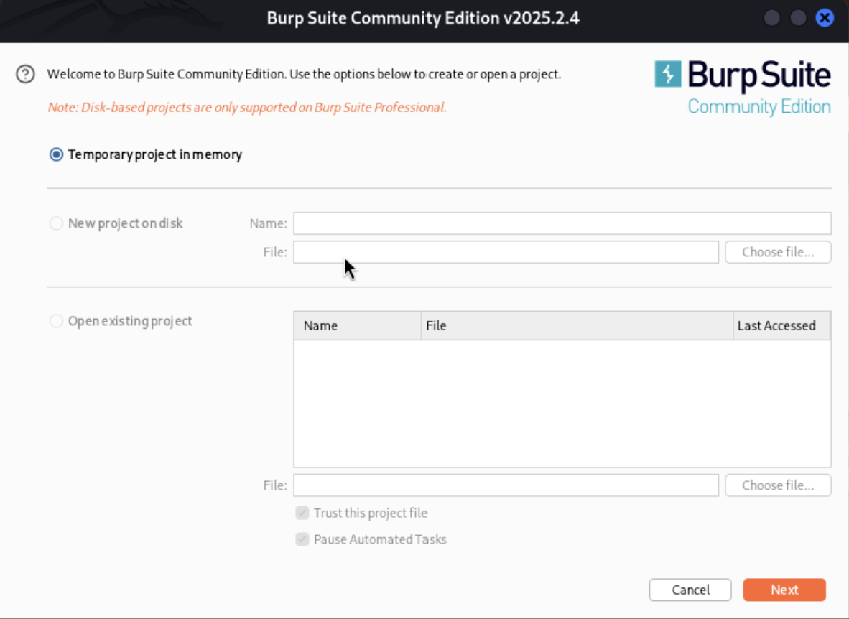

- Click on proxy tab and go to Proxy settings

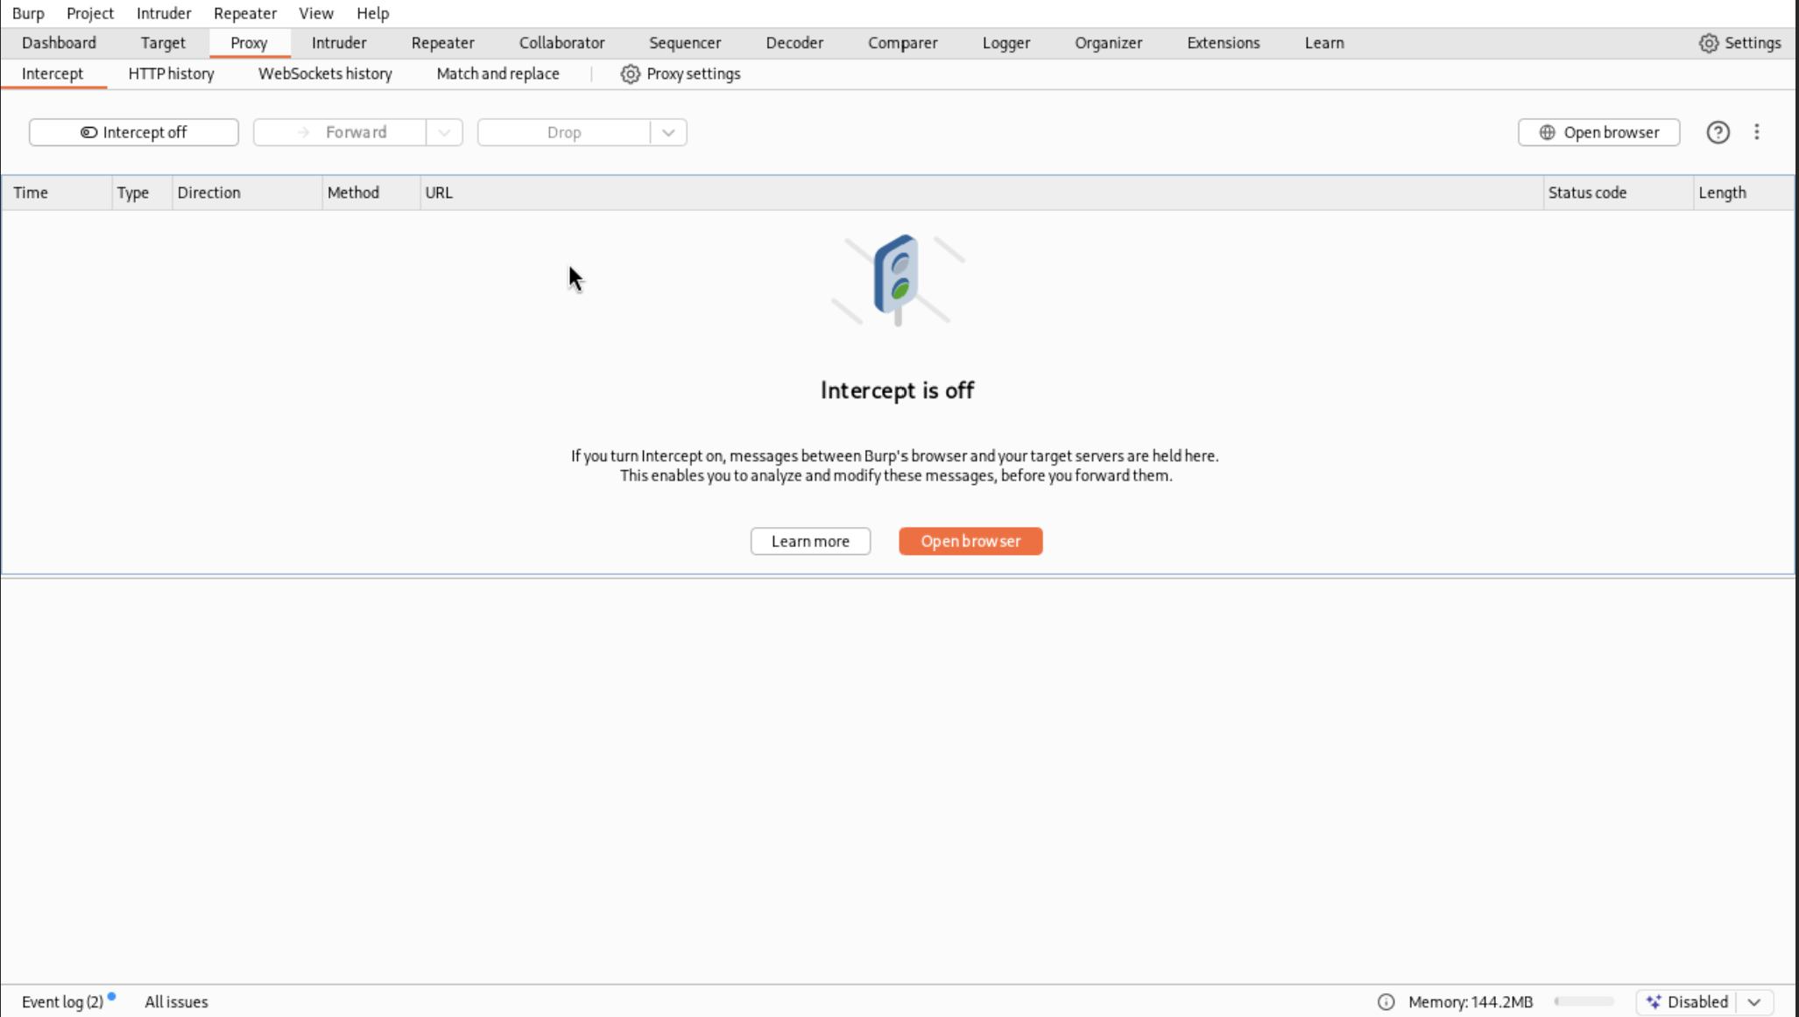
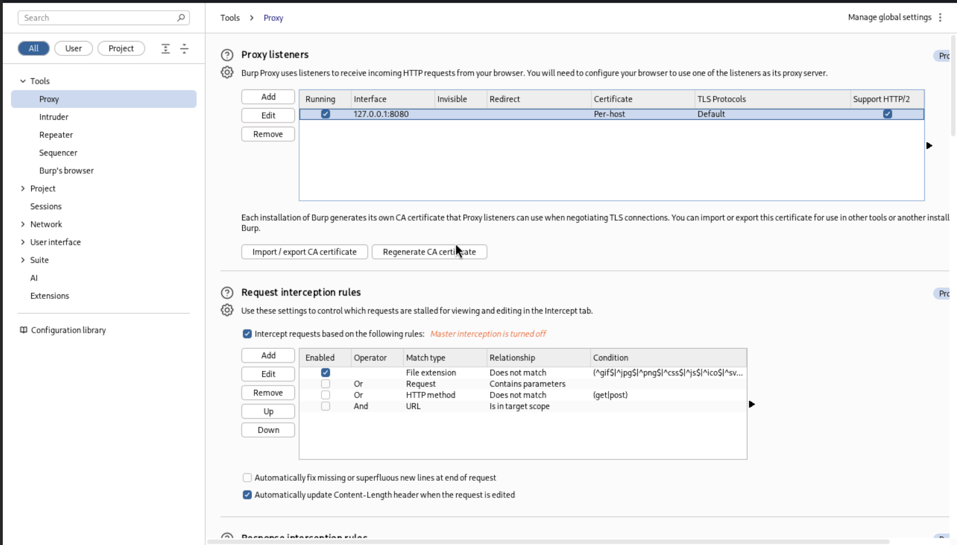

- Add the ip address and the port which you get to the foxy proxy and save then select it

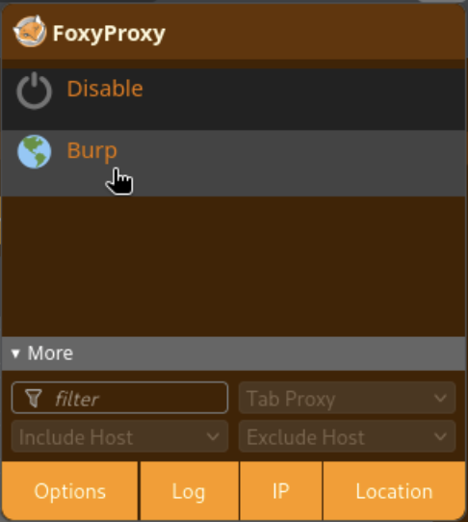

- Select intercept on and open browser and browse something

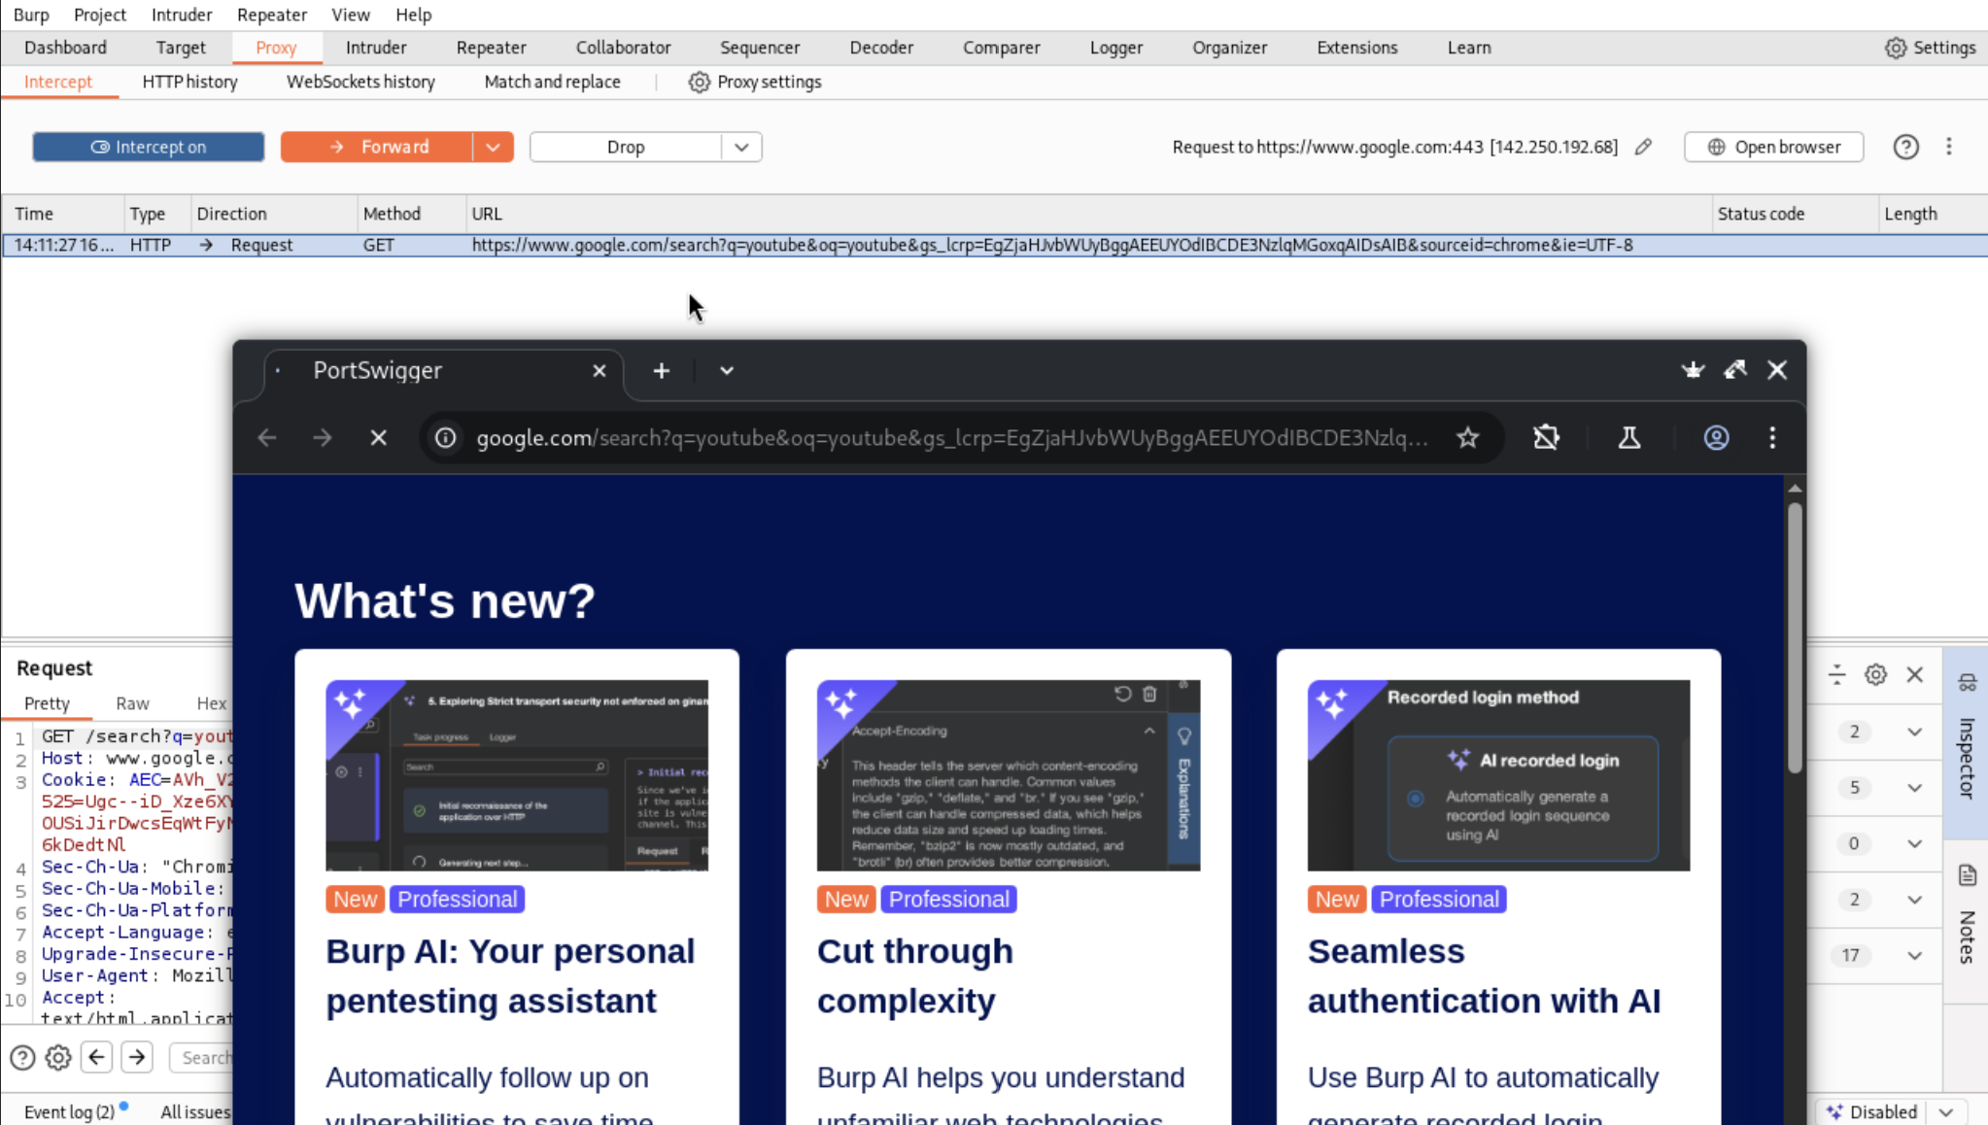

- It will prevent you from getting information cause we need to add the certificate from portswigger
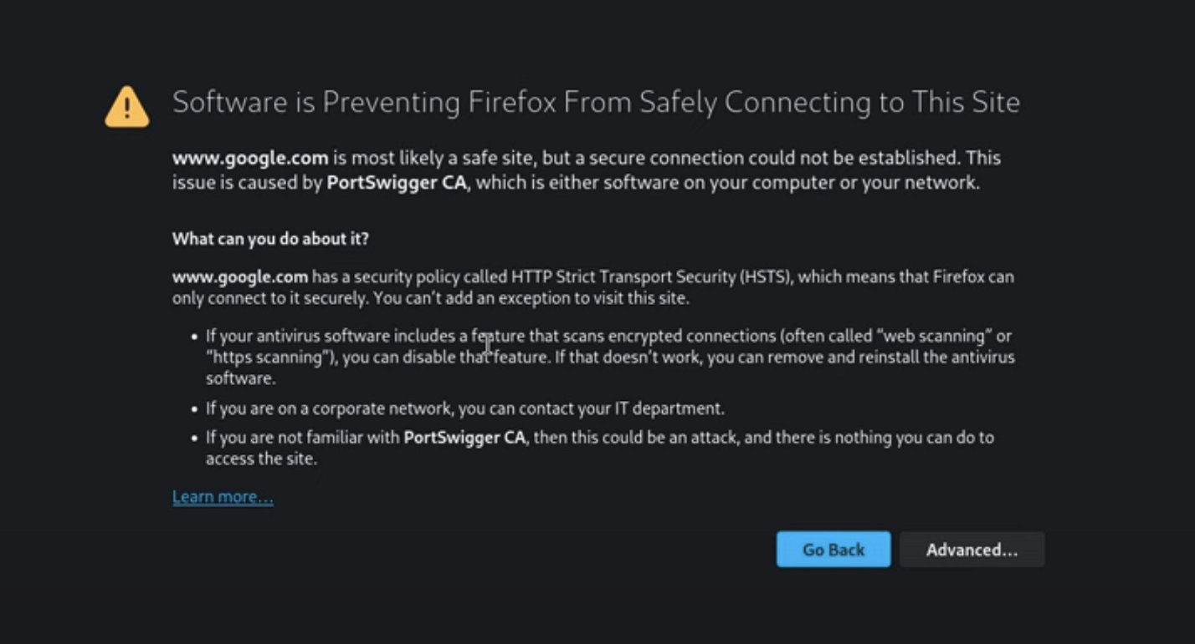

- Access the certificate on http://burp and click on the CA Certificate button and download the certificate

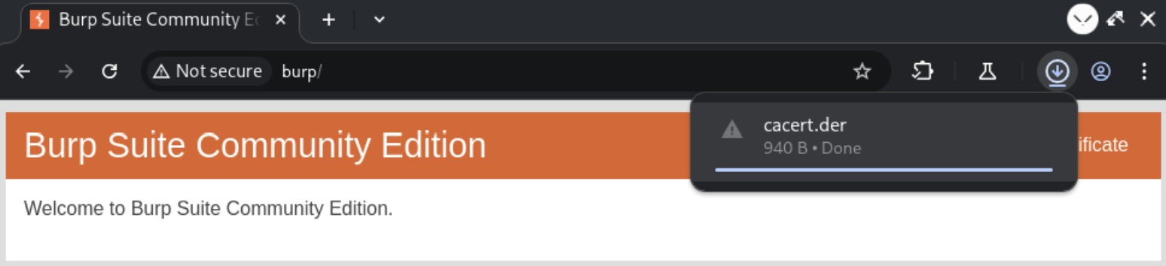

- Come back to your browser click on settings and go to the privacy and security tab and scroll down to the certificate section

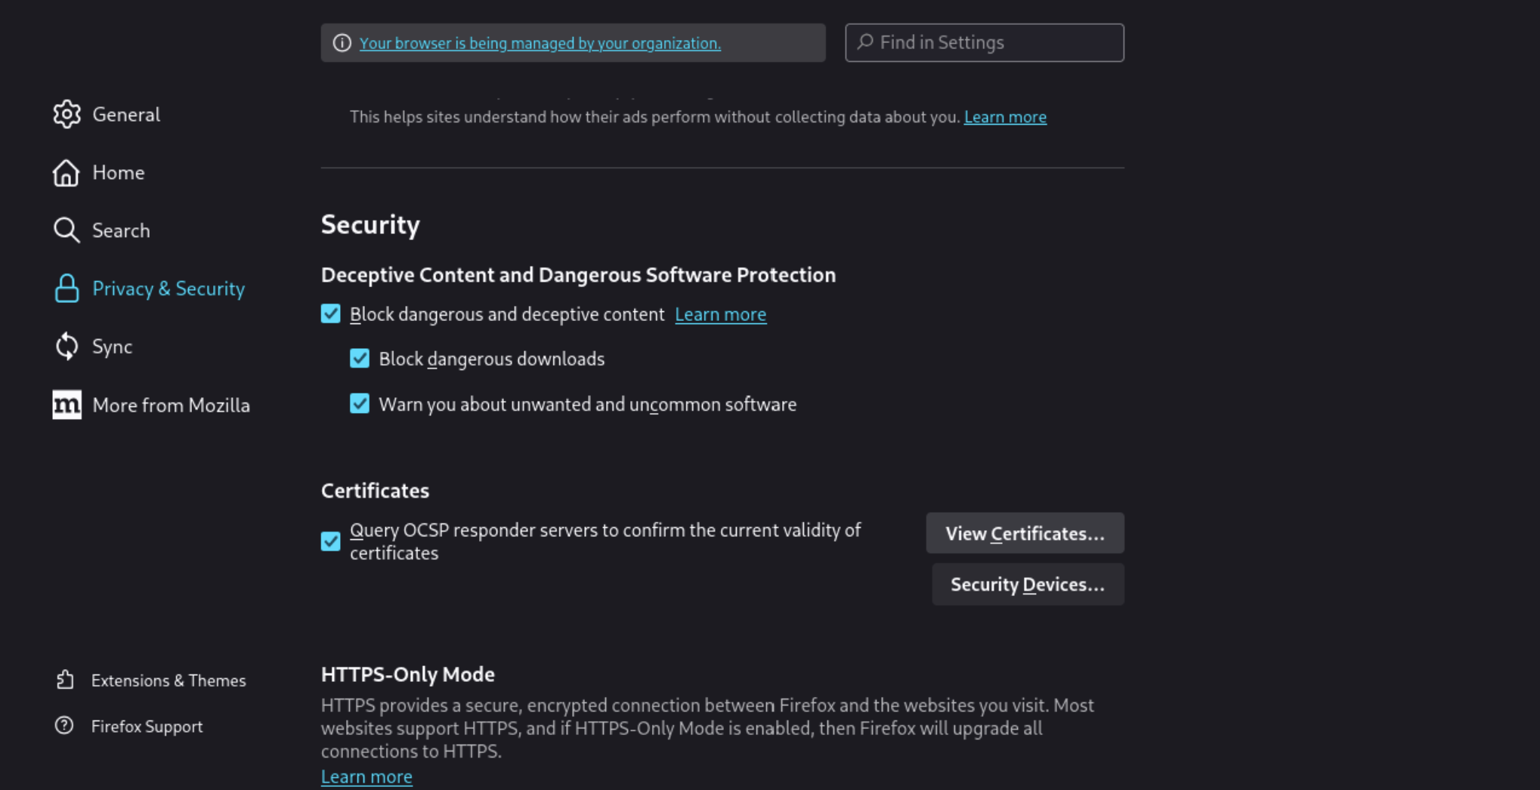

- Click on View Certificates and click on authority tab and select import
- Here select the certificate you downloaded and select both the boxes where it asks you to select the box if CA can identify both websites and email users

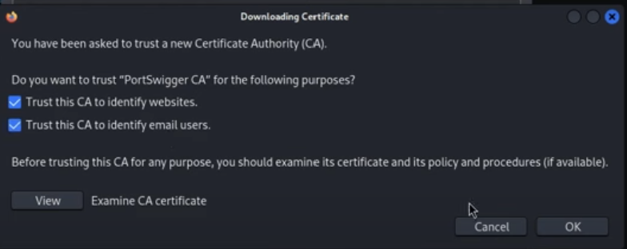

Step 5: Intercept Traffic
- Switch on the intercept
- Again, switch on Foxy Proxy turn Intercept on and enter the username and password in the login panel of the brute force and click on login

- Switch to Burp Suite and see the traffic

- After capturing the HTTP request, right click on it and select Send to Intruder, where the brute force attack will be conducted.

- After sending the request to Intruder, add the symbols around the parameter you want to brute force, indicating that the attack will be focused on that specific value.

- Select Simple List as the payload type to add potential passwords for the brute force attack. Using the Sniper attack type, Burp Suite will test each password individually to help identify the correct admin password .

- Now, click on Start attack to begin the brute force process and test the passwords .

- By verifying the response length, we determined that the correct password for the admin is password. The Content-Length header indicates the size of the HTTP response body in bytes. A successful login usually changes the content length compared to failed attempts, helping us identify the correct password based on this difference.

- Now, we will test the discovered password, and as shown below, we have successfully identified the correct one, confirming our brute force attempt was successful.

- Mitre Tactics and Techniques
Tactics | Techniques
Credential Access | Brute Force (T1110), Credential Stuffing (T1110.004) - The walkthrough uses a simple password list and an automated tool to find the correct credentials

- Conclusion

- This walkthrough effectively demonstrates the mechanics of a brute force attack against a web application login page.
- It highlights a critical vulnerability where an unmitigated login form can be exploited to guess credentials.
- The exercise, using tools like Hydra and Burp Suite, showcases how an attacker can systematically test a list of common passwords to gain unauthorized access.
- The success of this attack underscores the importance of implementing robust security measures, such as rate-limiting failed login attempts, using strong password policies, and employing multi-factor authentication, to protect web applications from credential-guessing attacks

